Make Oakland County Green
2020 Oakland County Climate, Jobs and Justice Platform

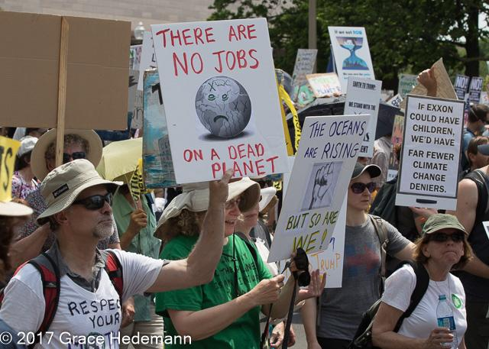
Climate
- Create Sustainability Office.
- Net-zero emissions for county operations by 2030.
- Net-zero countywide by 2050, using renewables.
- Protect vulnerable people from climate change. Preserve affordability.
- Invest in green business and good green jobs.
- Cleanup toxic sites and hold polluters responsible.

Energy Justice
- Support energy efficiency programs for low-income.
- Press utilities to invest in low-income areas.
- Ensure equitable transition for workers and residents.

Transit & Transportation
- Develop Woodward corridor with low-carbon transit options.
- Develop plan for light rail commuter system with a Detroit hub.
- Modernize transit stops and services.
- Support charging stations for electric vehicles.
- Focus on shared mobility rather than wider roads.
Clean Water
- Secure funds to replace all lead service lines - most vulnerable people first.
- Promote stormwater utilities.
- Promote native plant use by governments and homeowners.
- Prevent pollution from septic systems and institute inspection requirements.

Democratic Access
- Work to expand voting franchise, eliminate partisan gerrymandering.
- Develop clerk relations to help protect the rights enshrined in proposal three (2018).
- Develop and expand voter education so people know their rights.

